

Introduction to Database

Group Project

On

School management system

|  |
| --- |
| Submitted to.....  Rifat Tasnim Anannya |

|  |
| --- |
| Submitted by …..  Muhtasim Ahmed 17-35705-3  Shahriar Ahmed 18-36926-1  MD. Fahad Molla 18-36702-1  Faria Farzana Dola 18-36412-1 |

Index

|  |  |
| --- | --- |
| Title | Page |
| Project scenario | 3 |
| ER Diagram | 4 |
| Normalization | 5 to 7 |
| Table creation | 8 to 10 |
| Joining | 11 to 12 |
| Sub query | 13 to 14 |
| Constraint | 15 to 16 |

Project Scenario

School management system:

Officers manage students and teachers. Officers have unique id, name phone and address. Students go to school. Students have unique student id, name, address and phone number. Teachers teach student. Teachers have unique teacher’s id, name, email, address and phone. Teachers take classes. Classes have unique room number and date.

ER Diagram

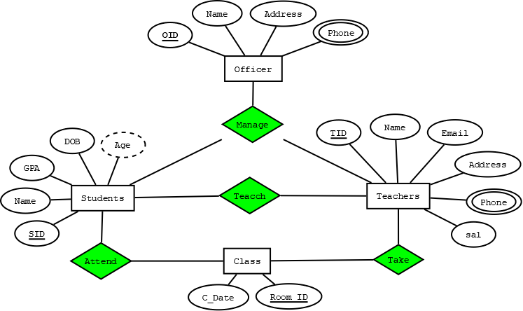

Normalization

Officer

|  |  |  |  |
| --- | --- | --- | --- |
| OID | NAME | ADDRESS | PHONE |
| 1 | Abdur , rohman | Rampura | 01712345678 |
| 2 | Rohim , miyah | Motijheel | 01723456789 |
| 3 | Borkot , shah | Badda | 01734567891 |
| 4 | Rohmot , ali | Kuril | 01745678901 |
| 5 | Obaidur , islam | Uttora | 01756789012 |

Teacher

|  |  |  |  |  |  |
| --- | --- | --- | --- | --- | --- |
| TID | NAME | SAL | EMAIL | ADDRESS | PHONE |
| 100001 | Munni , shaha | 5000 | munni@gmail | Dhanmondi | 01767890123 |
| 100002 | Abdul , alom | 4500 | alom@gmail | Gulshan | 01778901234 |
| 100003 | Rowshan , ara | 4000 | ara@gmail | New market | 01789012345 |
| 100004 | Nazrul , islam | 3500 | isalm@gmail | Farm gate | 01790123456 |
| 100005 | Nipa , ahmed | 3000 | nipa@gmail | Airport | 01710012345 |

Student

|  |  |  |  |  |  |
| --- | --- | --- | --- | --- | --- |
| SID | NAME | GPA | DOB | AGE | ADDRESS |
| 01 | Emon , rohman | 4.94 | 26-09-12 | 6 | Mohakhali |
| 02 | Priam , foyzur | 3.15 | 20-10-09 | 9 | Mohammedrpur |
| 03 | Shaiful , alom | 2.5 | 15-5-10 | 8 | Bonani |
| 04 | Joshim , haque | 4.5 | 18-6-13 | 5 | Nikunja |
| 05 | Mina , akter | 3.5 | 6-2-14 | 4 | Komlapur |

Class

|  |  |
| --- | --- |
| ROOM_ID | C_DATE |
| 1001 | 8-9-18 |
| 1002 | 9-5-18 |
| 1003 | 10-4-18 |
| 2001 | 20-6-18 |
| 2002 | 15-2-18 |

Normalization: 1NF

Officer

|  |  |  |  |  |
| --- | --- | --- | --- | --- |
| OID | F_NAME | L_NAME | ADDRESS | PHONE |
| 1 | Abdur | Rohman | Rampura | 01712345678 |
| 2 | Rohim | Miyah | Motijheel | 01723456789 |
| 3 | Borkot | Shah | Badda | 01734567891 |
| 4 | Rohmot | Ali | Kuril | 01745678901 |
| 5 | Obaidur | Islam | Uttora | 01756789012 |

Teacher

|  |  |  |  |  |  |  |
| --- | --- | --- | --- | --- | --- | --- |
| TID | F_NAME | L_NAME | SAL | EMAIL | ADDRESS | PHONE |
| 100001 | Munni | Shaha | 5000 | munni@gmail | Dhanmondi | 01767890123 |
| 100002 | Abdul | Alom | 4500 | alom@gmail | Gulshan | 01778901234 |
| 100003 | Rowshan | Ara | 4000 | ara@gmail | New market | 01789012345 |
| 100004 | Nazrul | Islam | 3500 | isalm@gmail | Farm gate | 01790123456 |
| 100005 | Nipa | Ahmed | 3000 | nipa@gmail | Airport | 01710012345 |

Student

|  |  |  |  |  |  |  |
| --- | --- | --- | --- | --- | --- | --- |
| SID | F_NAME | L_NAME | GPA | DOB | AGE | ADDRESS |
| 01 | Emon | Rohman | 4.94 | 26-09-12 | 6 | Mohakhali |
| 02 | Foyzur | Priam | 3.15 | 20-10-09 | 9 | Mohammedrpur |
| 03 | Shaiful | Alom | 2.5 | 15-5-10 | 8 | Bonani |
| 04 | Joshim | Haque | 4.5 | 18-6-13 | 5 | Nikunja |
| 05 | Mina | Akter | 3.5 | 6-2-14 | 4 | Komlapur |

Class

|  |  |
| --- | --- |
| ROOM_ID | C_DATE |
| 1001 | 8-9-18 |
| 1002 | 9-5-18 |
| 1003 | 10-4-18 |
| 2001 | 20-6-18 |
| 2002 | 15-2-18 |

Normalization: 2NF & 3NF

Officer

|  |  |  |  |  |  |  |
| --- | --- | --- | --- | --- | --- | --- |
| OID | F_NAME | L_NAME | ADDRESS | PHONE | TID | SID |
| 1 | Abdur | Rohman | Rampura | 01712345678 | 100001 | 01 |
| 2 | Rohim | Miyah | Motijheel | 01723456789 | 100002 | 02 |
| 3 | Borkot | Shah | Badda | 01734567891 | 100003 | 03 |
| 4 | Rohmot | Ali | Kuril | 01745678901 | 100004 | 04 |
| 5 | Obaidur | Islam | Uttora | 01756789012 | 100005 | 05 |

Teacher

|  |  |  |  |  |  |  |  |
| --- | --- | --- | --- | --- | --- | --- | --- |
| TID | F_NAME | L_NAME | SAL | EMAIL | ADDRESS | PHONE | SID |
| 100001 | Munni | Shaha | 5000 | munni@gmail | Dhanmondi | 01767890123 | O1 |
| 100002 | Abdul | Alom | 4500 | alom@gmail | Gulshan | 01778901234 | O2 |
| 100003 | Rowshan | Ara | 3000 | ara@gmail | New market | 01789012345 | O3 |
| 100004 | Nazrul | Islam | 3500 | isalm@gmail | Farm gate | 01790123456 | O4 |
| 100005 | Nipa | Ahmed | 3000 | nipa@gmail | Airport | 01710012345 | O5 |

Student

|  |  |  |  |  |  |  |  |
| --- | --- | --- | --- | --- | --- | --- | --- |
| SID | F_NAME | L_NAME | GPA | DOB | AGE | ADDRESS | ROOM_ID |
| 01 | Emon | Rohman | 4.94 | 26-09-12 | 6 | Mohakhali | 1001 |
| 02 | Foyzur | Priam | 3.15 | 20-10-09 | 9 | Mohammedrpur | 1002 |
| 03 | Shaiful | Alom | 2.5 | 15-5-10 | 8 | Bonani | 1003 |
| 04 | Joshim | Haque | 4.5 | 18-6-13 | 5 | Nikunja | 2001 |
| 05 | Mina | Akter | 3.5 | 6-2-14 | 4 | Komlapur | 2002 |

Class

|  |  |
| --- | --- |
| ROOM_ID | C_DATE |
| 1001 | 8-9-18 |
| 1002 | 9-5-18 |
| 1003 | 10-4-18 |
| 2001 | 20-6-18 |
| 2002 | 15-2-18 |

Class_info

|  |  |  |
| --- | --- | --- |
| C_Info | TID | ROOM |
| 96 | 100001 | 1001 |
| 97 | 100002 | 1002 |
| 98 | 100005 | 1003 |
| 99 | 100004 | 2001 |
| 100 | 100005 | 2002 |

Table creation

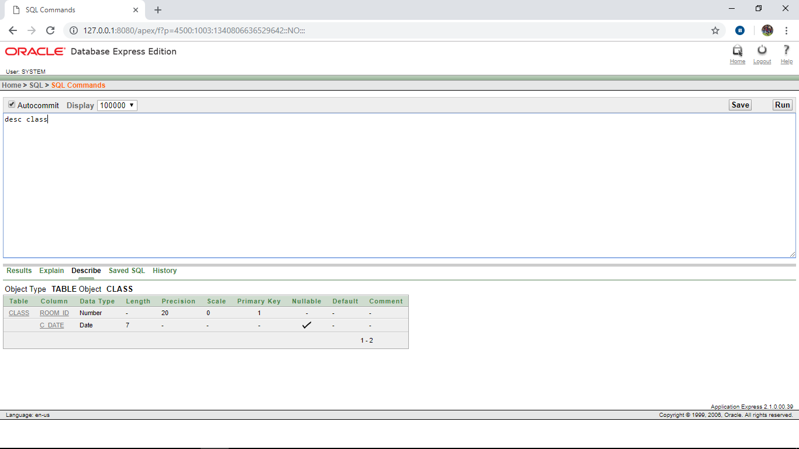

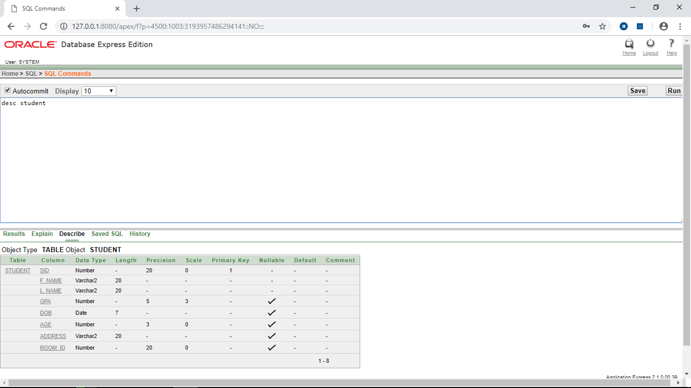

Table creation

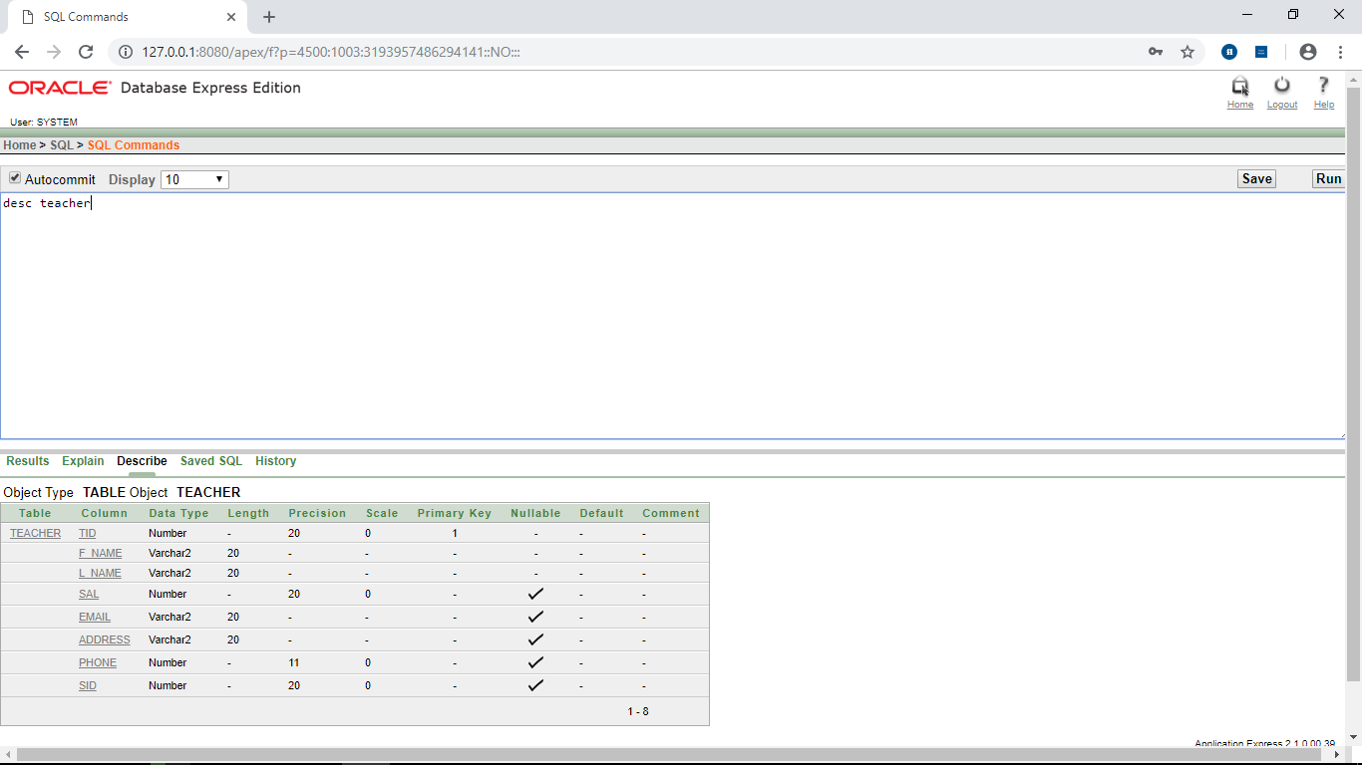

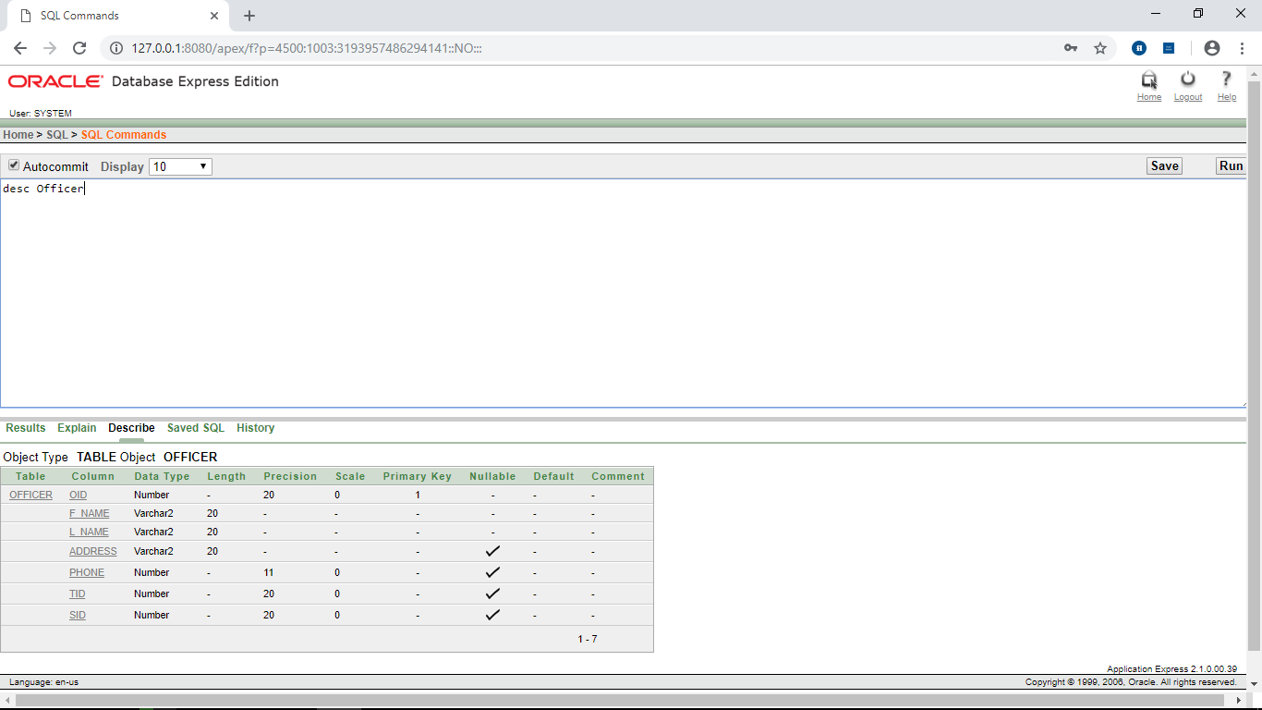

Table creation

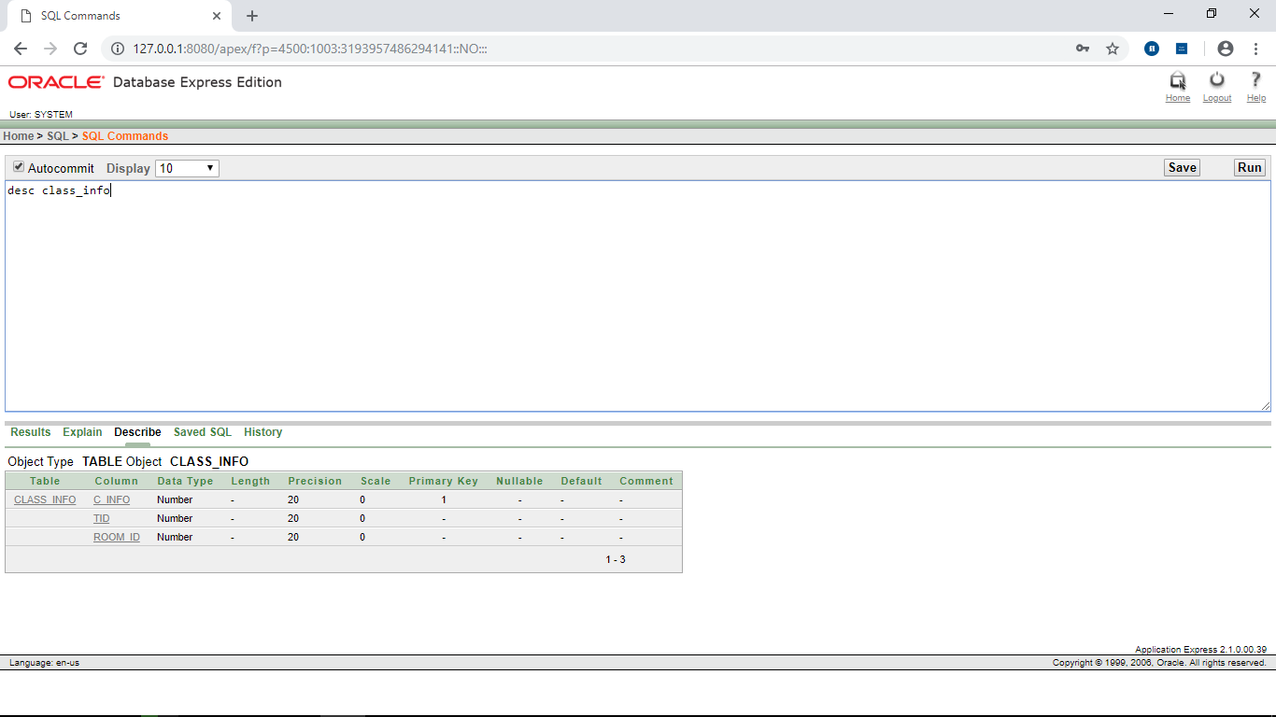

Joining

Find the student first name and last name along with room id of that student how read in room no 2002

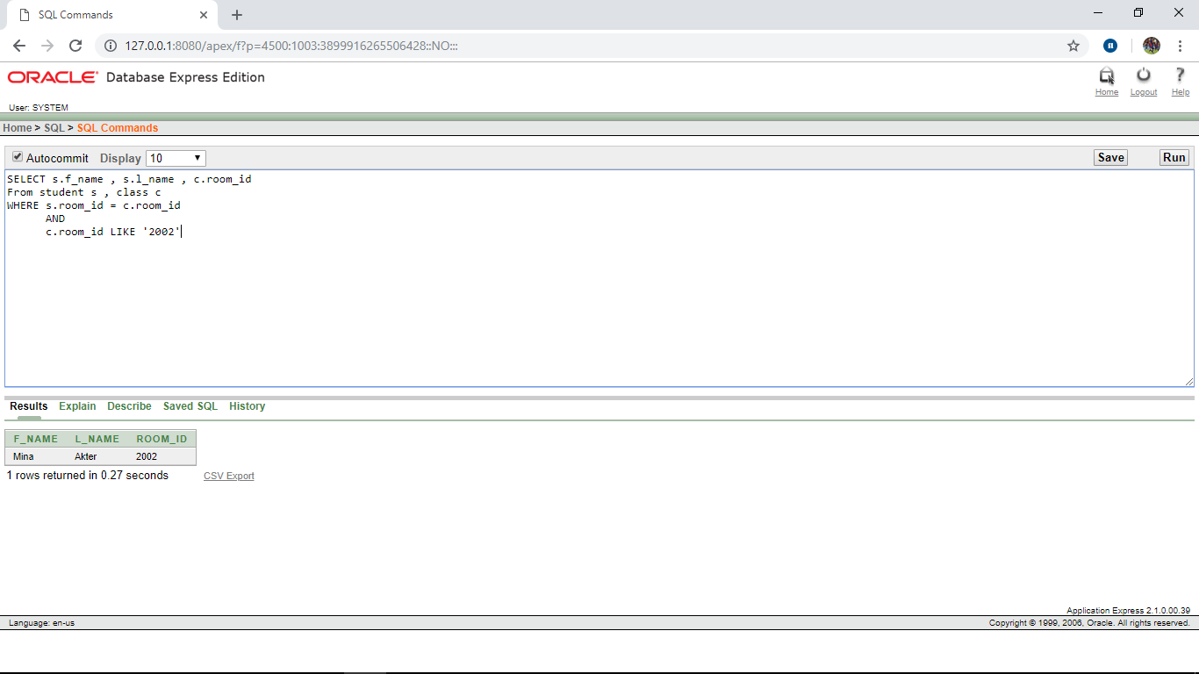

Display the first name and room id of that student how have “E” in his/her name

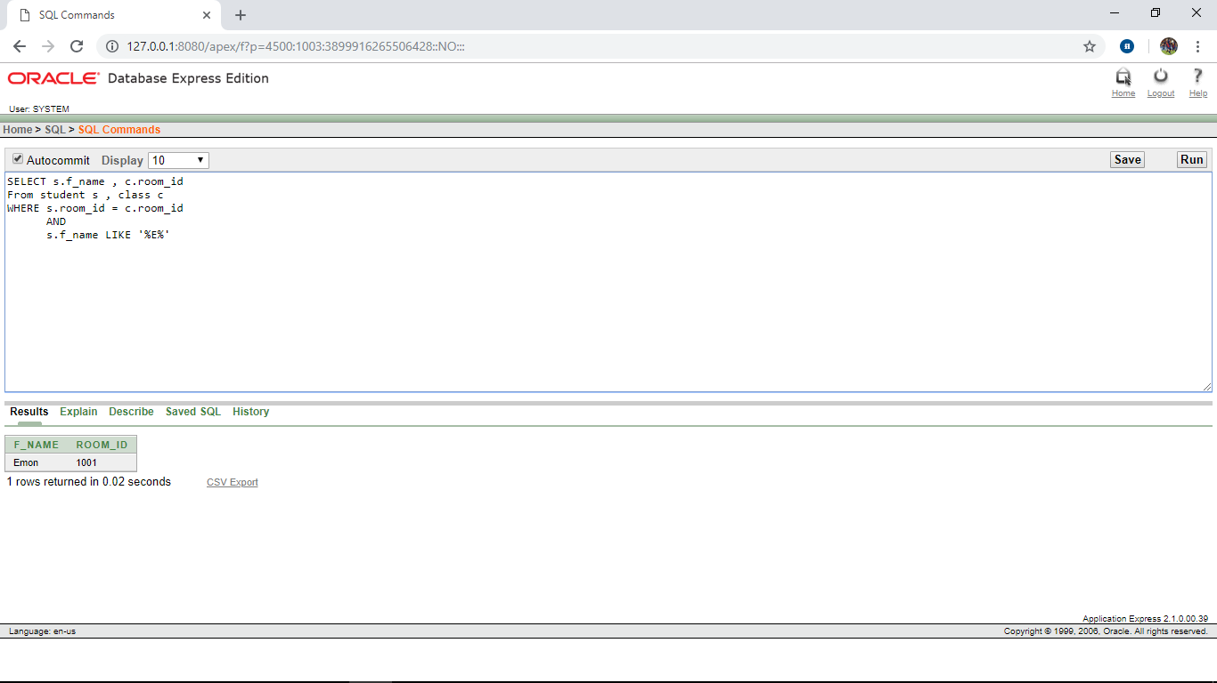

Joining

Display the first name and room id of all students

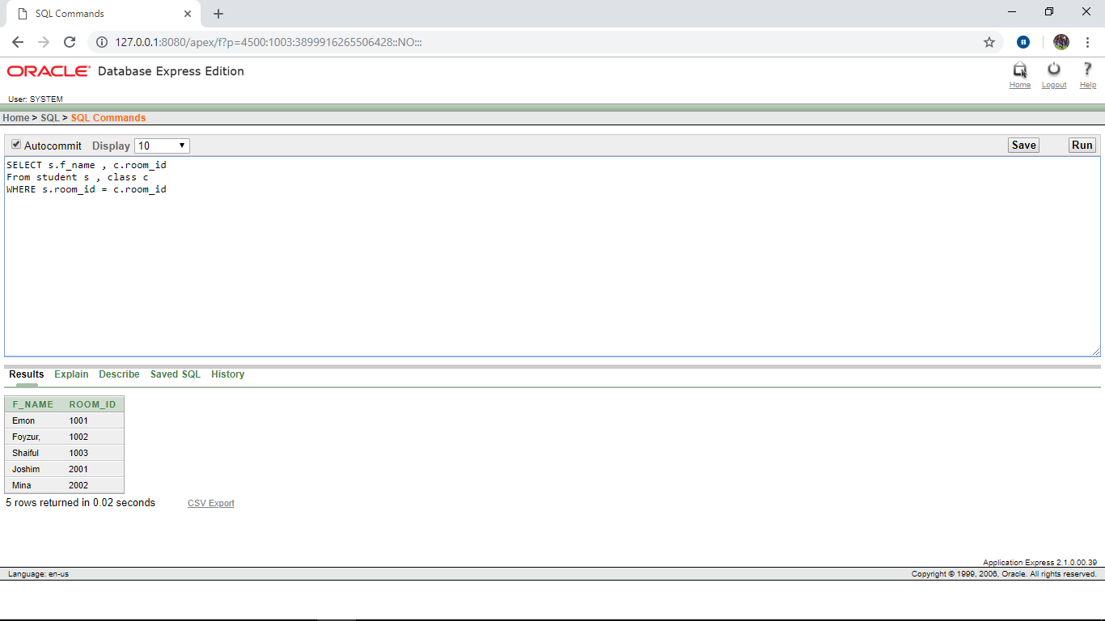

Display the first name and room id of the student how will attend class on 10-4-18

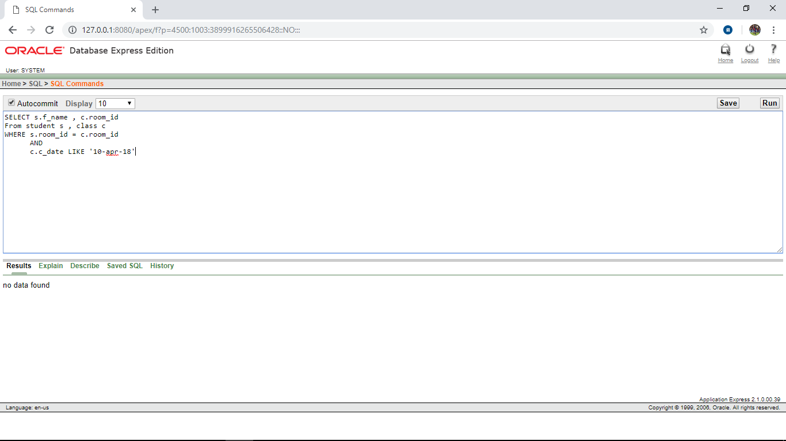

Sub query

Display the student first name, last name along with his or her GPA who have the lowest GPA.

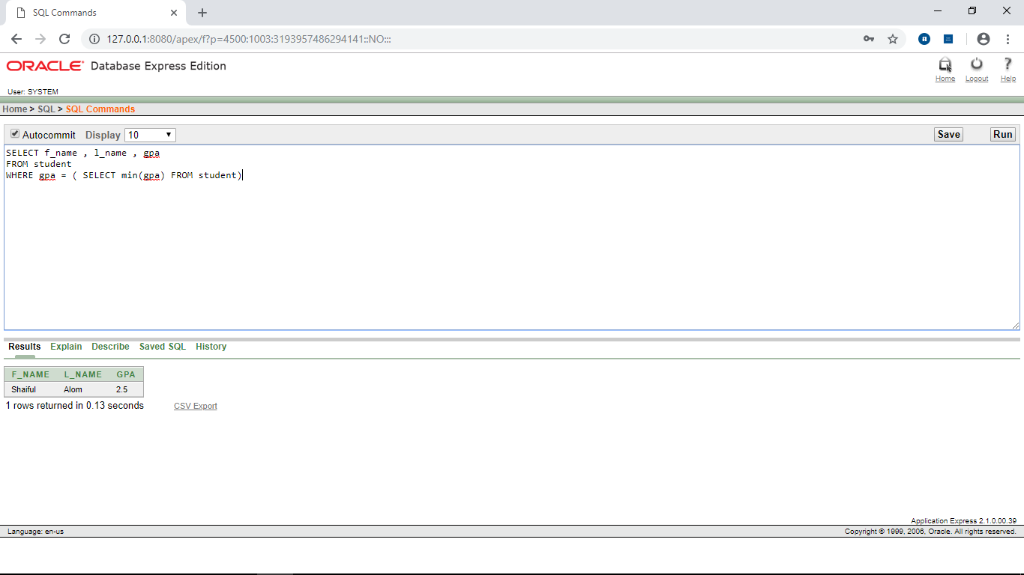Write a query to find the student id of the student who have a higher GPA then the student whose last name is ‘PRIAM’. 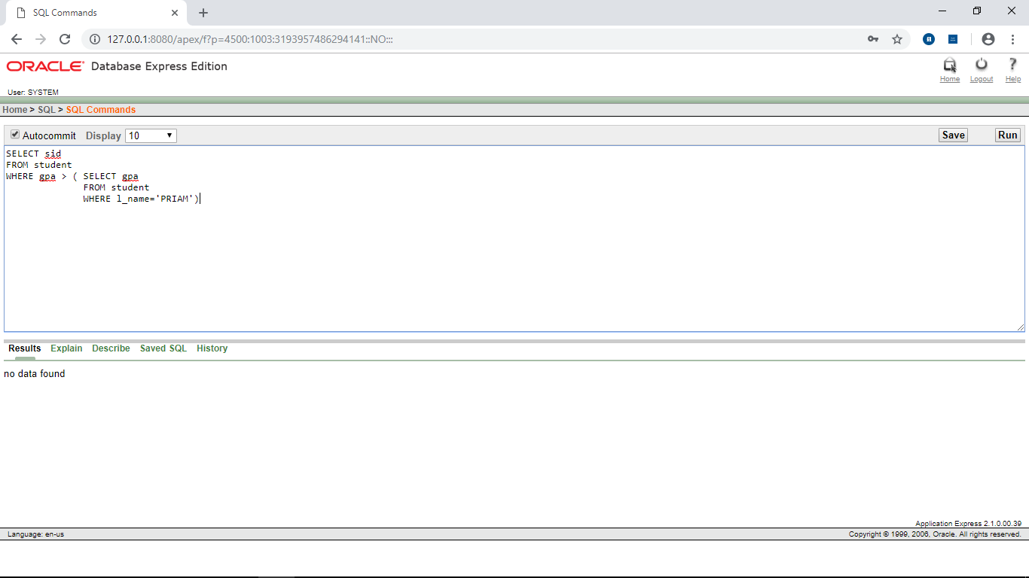

Sub query

Display the student first and last name who is smaller than ‘PRIAM’

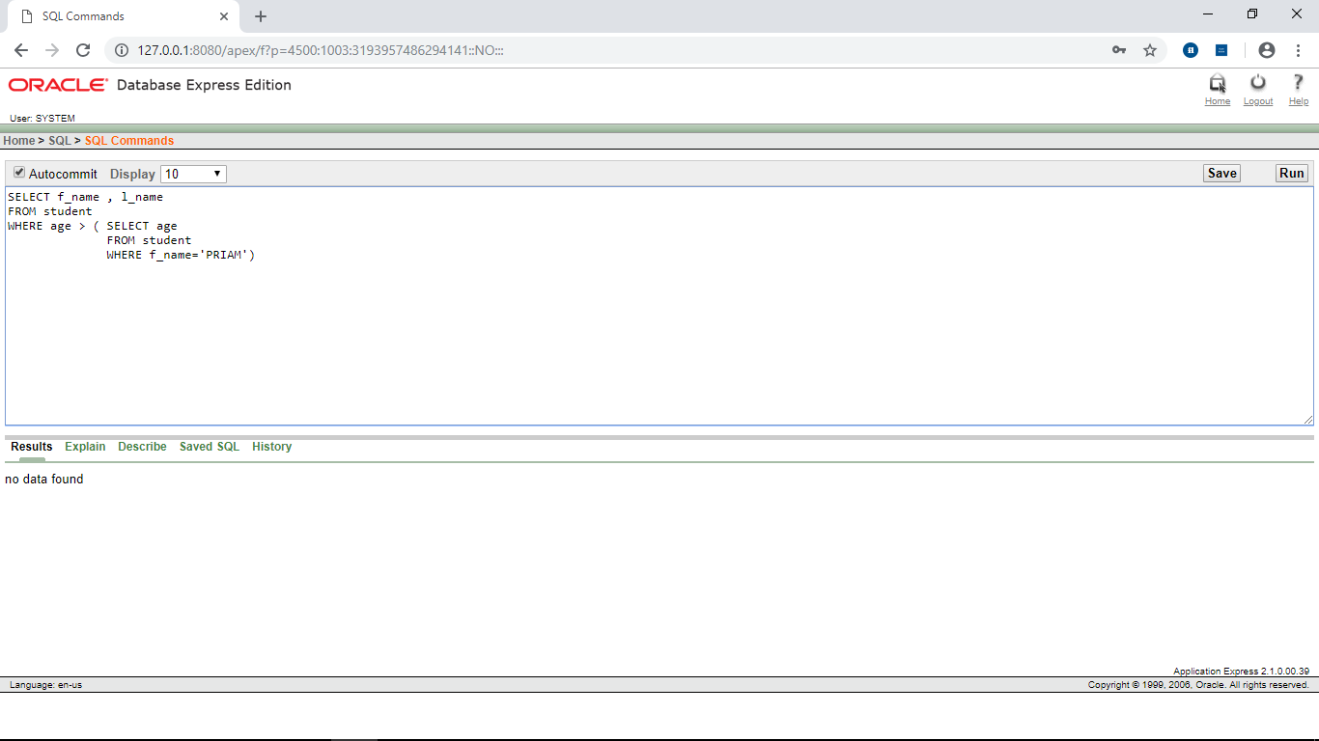

Find the sid of the student who have the highest GPA.

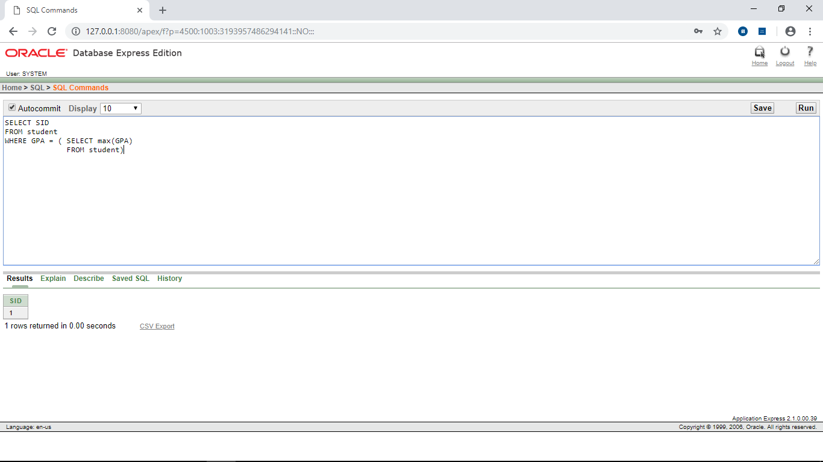

Constraint

Add Constraint:

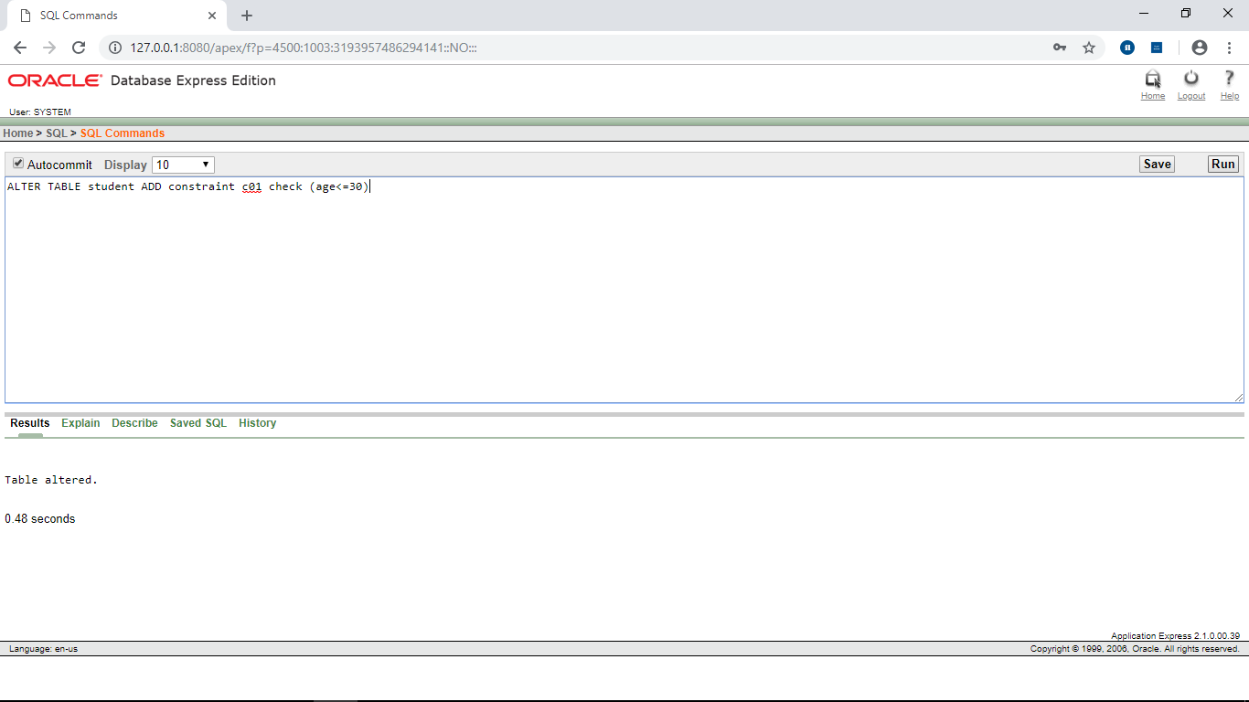

Disable Constraint:

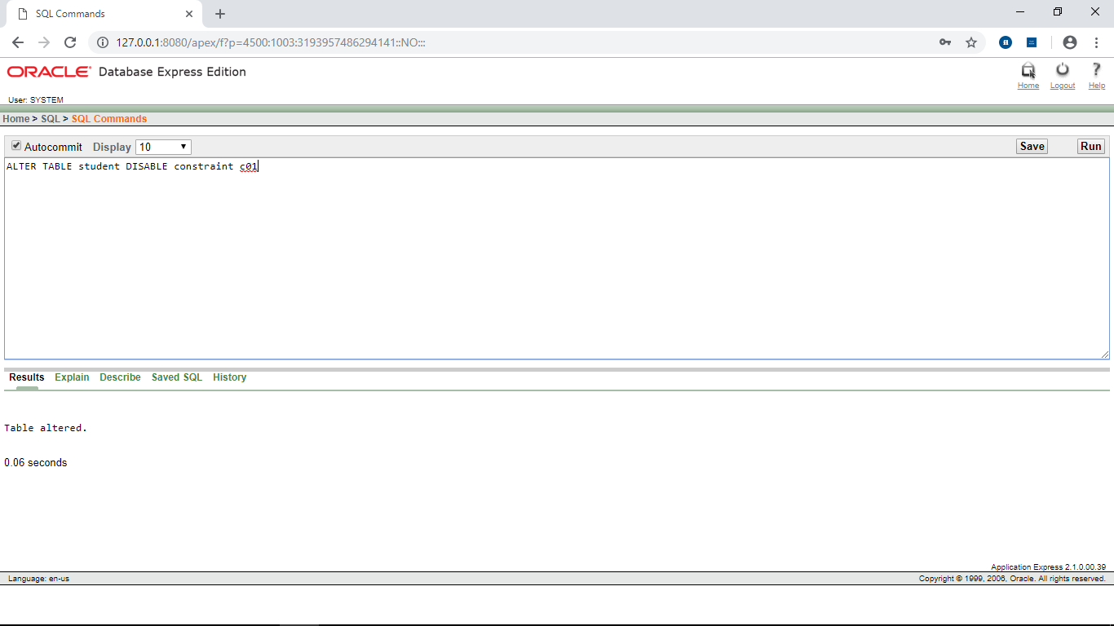

Constraint

Enable Constraint:

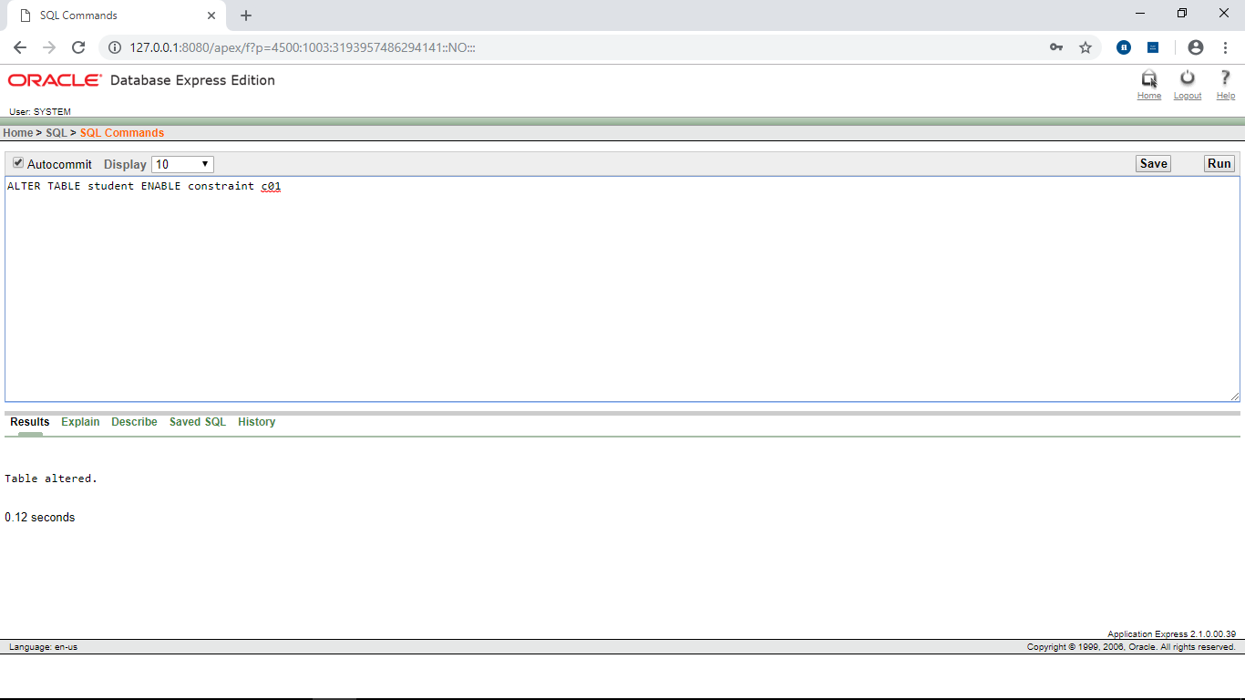

-----END-----